Guide to GrandeOmega (GO)

# Installation

* Download and install node.js (LTS) from: <https://nodejs.org/en/download/>
* Download and install Python from: <https://www.python.org/downloads/>
  + For Windows users, make sure to have Python added to your environment variables

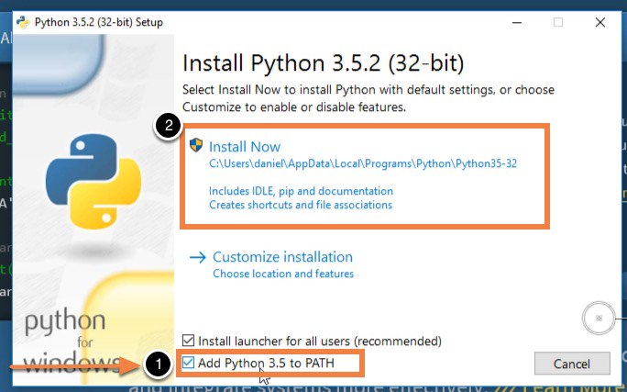

NOTE : clicking the box as shown in the previous image this will work most of the times. You can check if Python was successfully added to the environment variables by following the instructions in the following link: <https://www.architectryan.com/2018/03/17/add-to-the-path-on-windows-10/> )

* Download the client of GO from: <http://grandeomega.com/go_student_win.7z>
  + Note: the file is archived with 7zip (download it, if needed)
* Unzip the compressed folder downloaded at the previous step
* Execute the **GrandeOmega.exe** file:

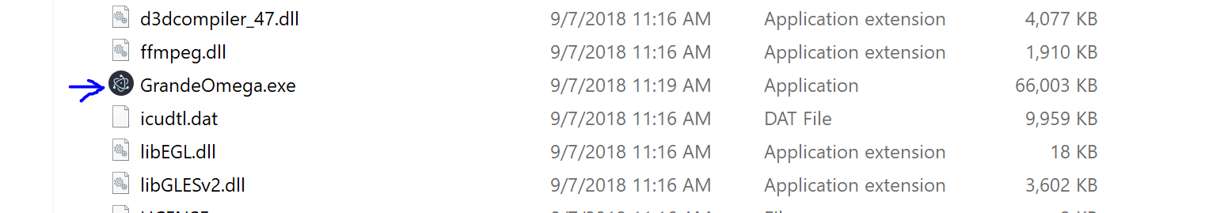

# Use

* After the client starts, you need to login with your credentials (you will receive via your student email instructions to get access):

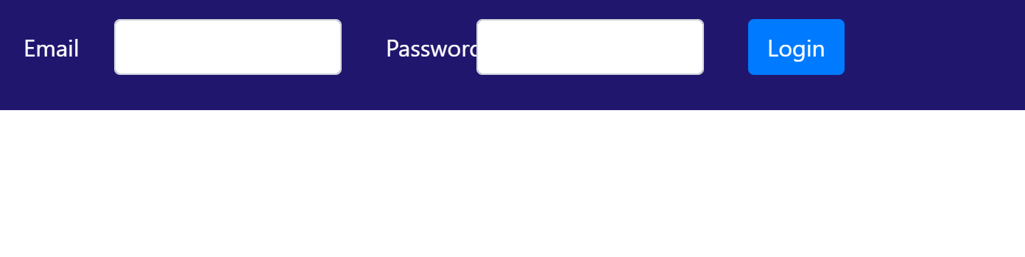

* After having logged in, you will see a screen with the courses you are subscribed to:

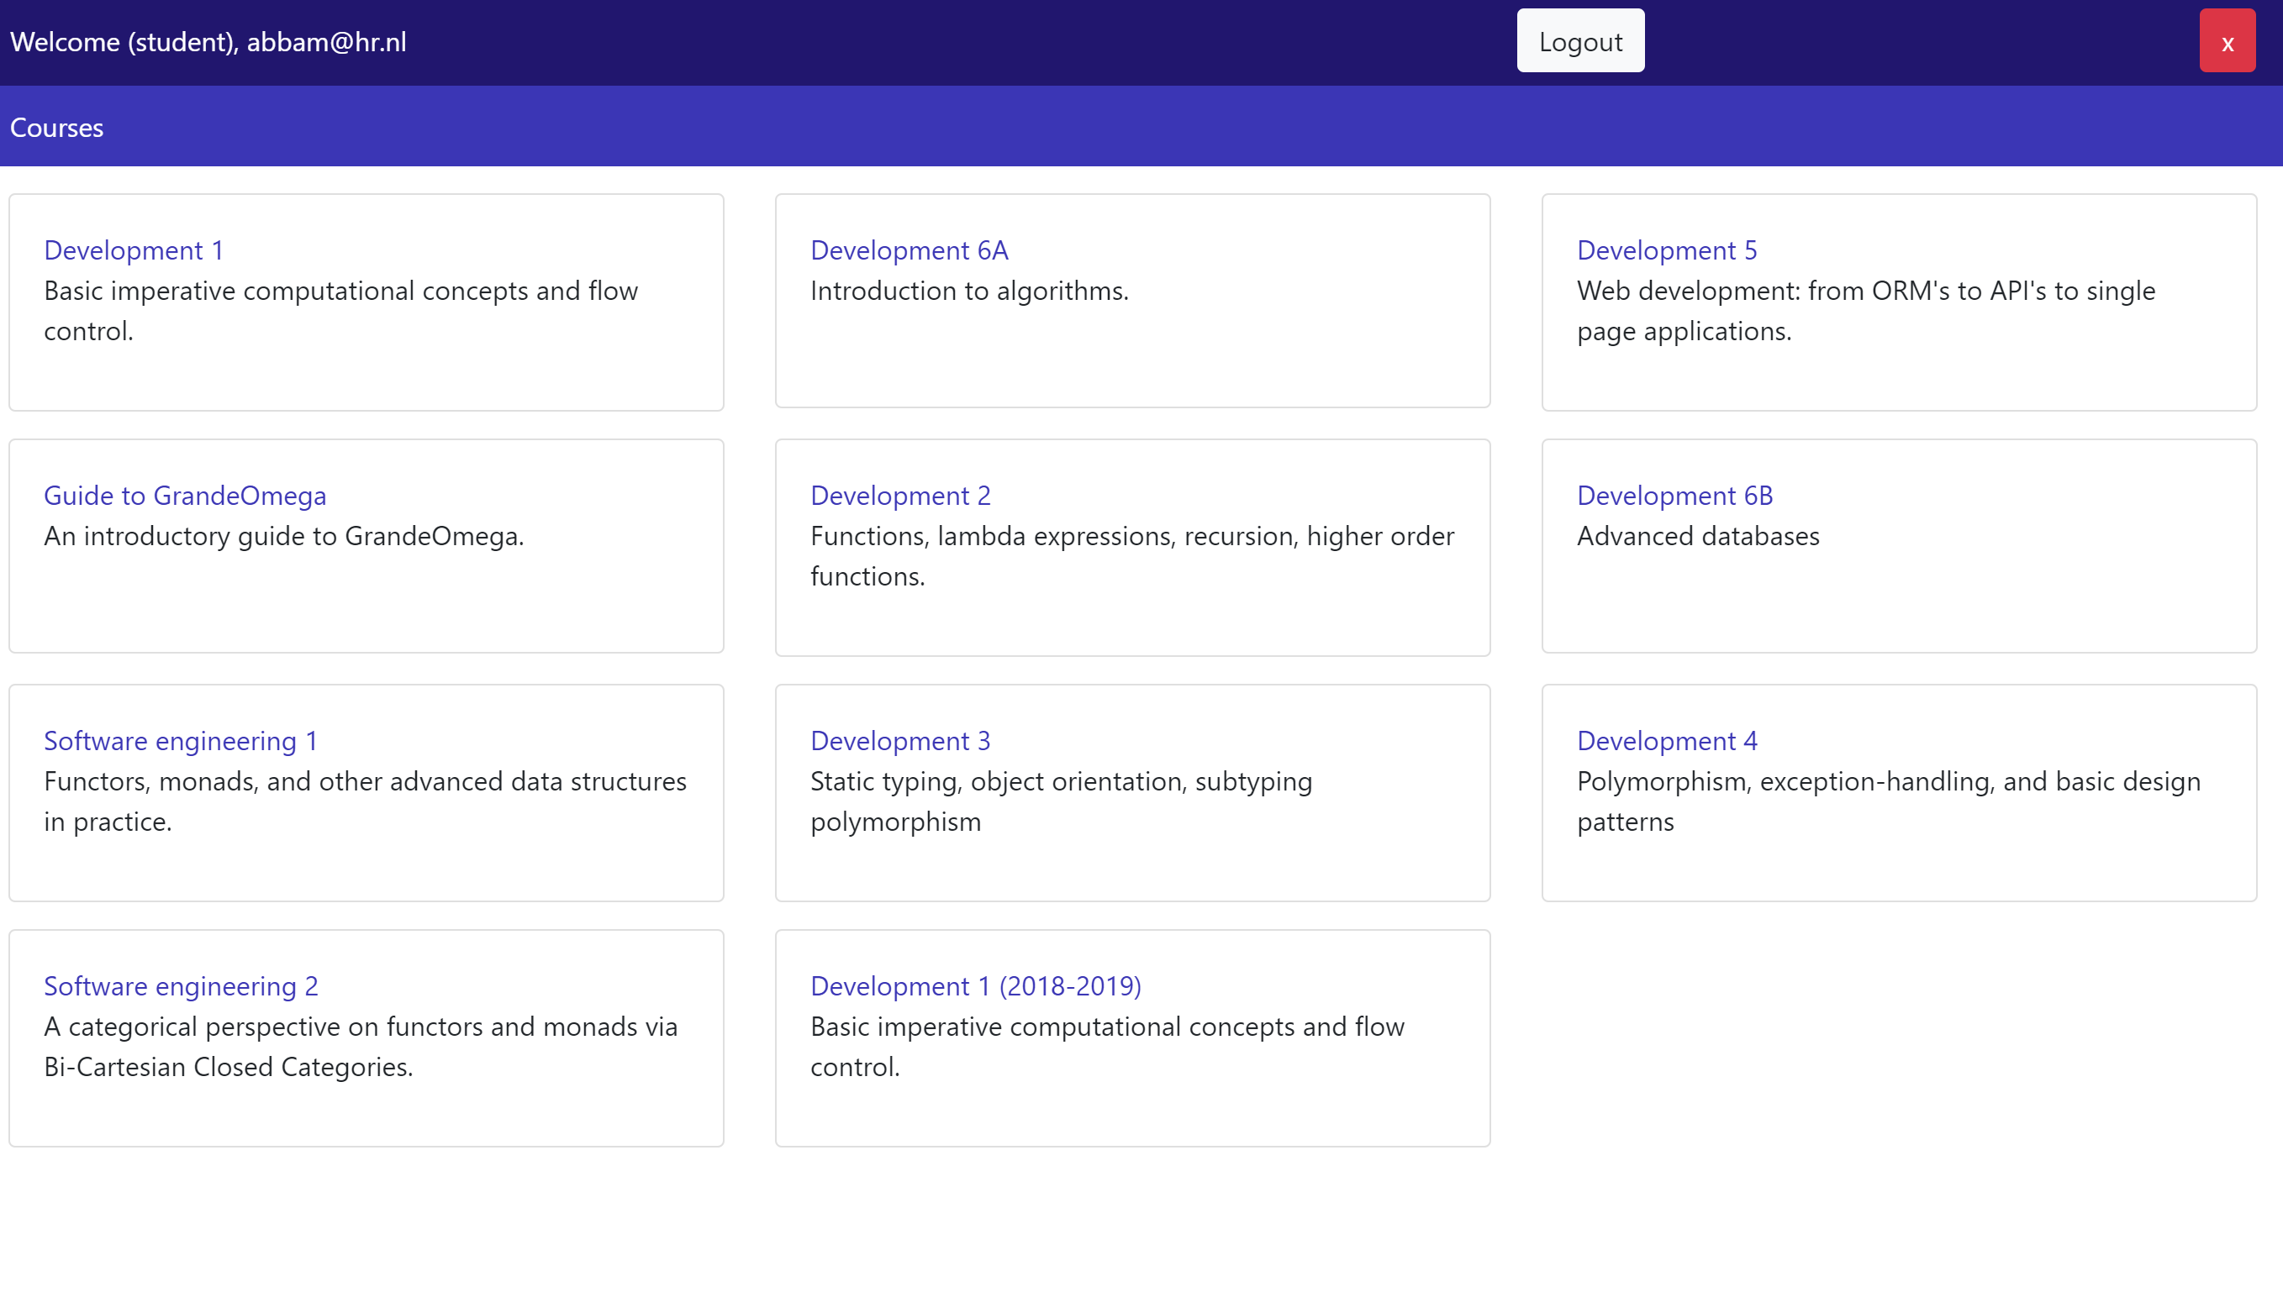

* Clicking on a course, you will see the chapters of materials available for such course:

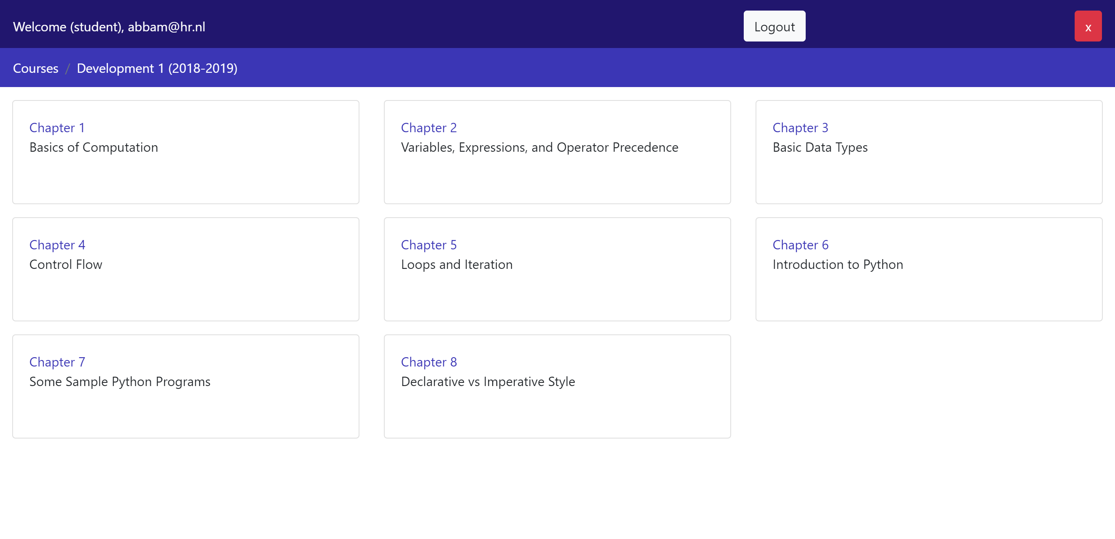

* Clicking on a chapter, you will see the materials associated to such chapter in a column on the left of the screen. Click on the name of an item to open its associated content.

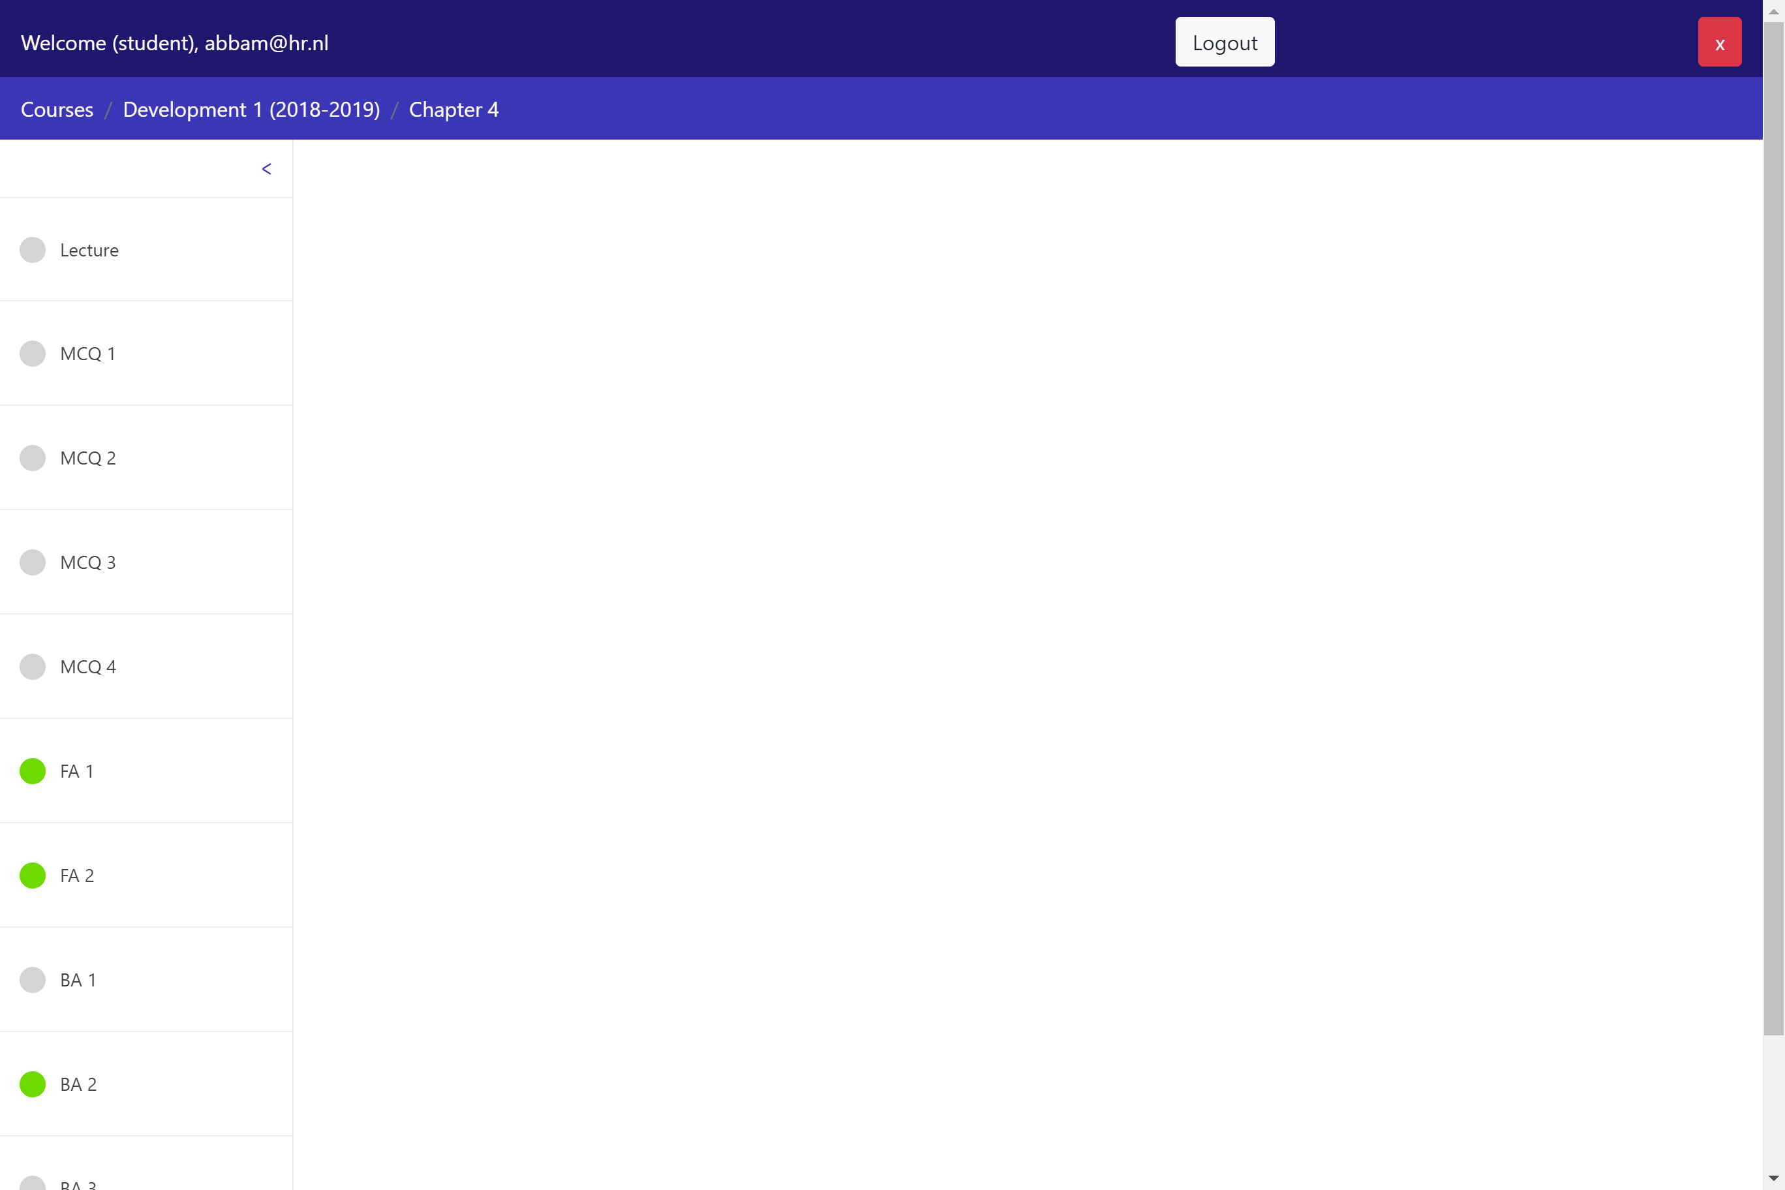

* A single chapter is usually composed by:
  + The reader of the corresponding lecture
  + A series of exercises which are a combination of:
    - Multiple Choice Questions (MCQ)
    - Forward Assignments (FA)
    - Backward Assignments (BA)
* During the practicums, the teachers will show you more in detail how to solve the Forward and Backward assignments.
* In short, a **Forward Assignment** shows you a program and the (sometimes incomplete) state associated to certain steps of the execution of such program (marked with red blocks to the left of the code). To solve a FA, you need to insert the missing values of variables in *all* incomplete states (remember to click “Next” until the last state is reached). For example:

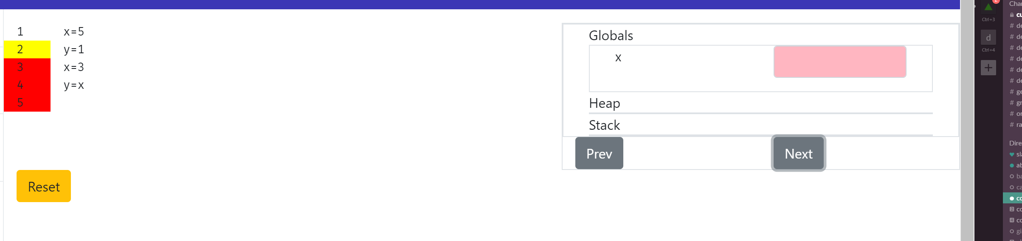

The state on the right (Globals, etc.) corresponds to the state of the program when the line of code marked with a yellow block is about to be executed (in the example above, when line 2 is about to be executed).

A **Backward assignment**, instead, shows you an incomplete program and the states associated to some steps of the execution of the complete program (again, marked by red/yellow blocks to the left of the code). By looking at such states, you should be able to fill in the missing parts of the program. For example:

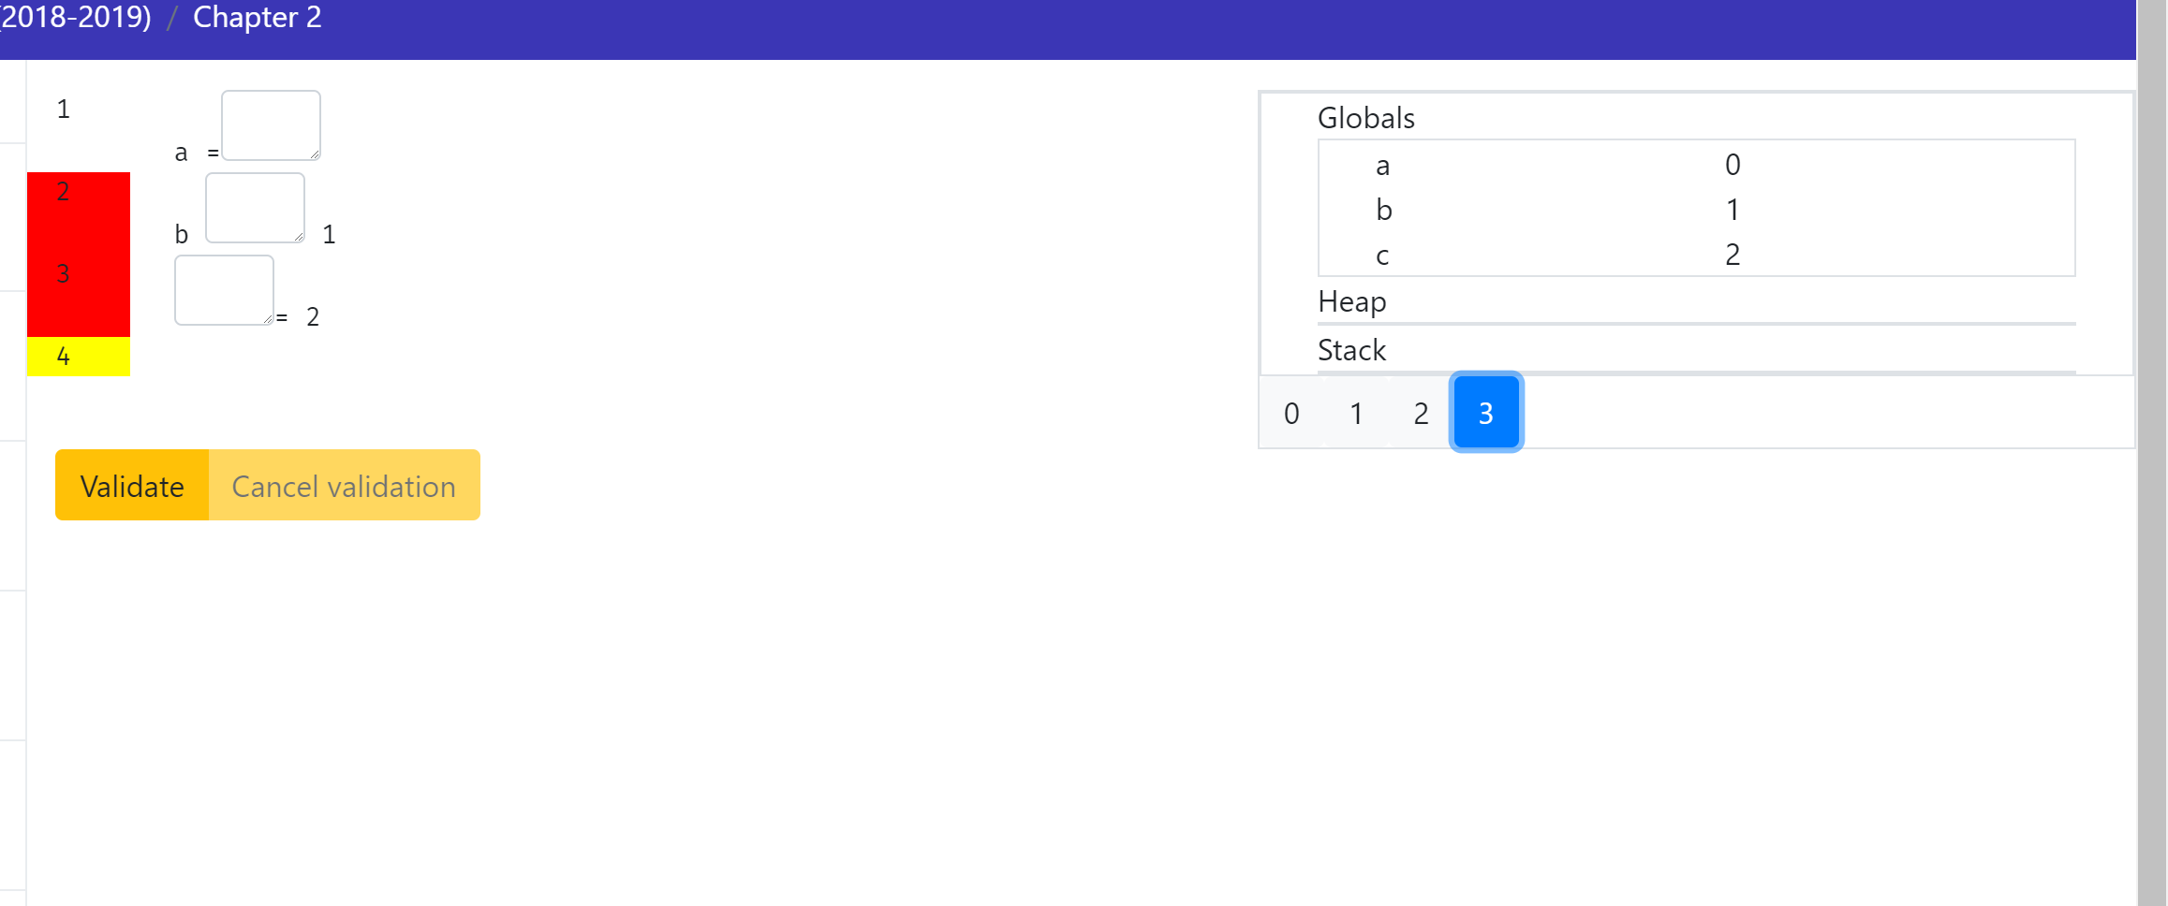

To see if your code solves the BA, click on “Validate” and you will get feedback.

When an assignment is correctly solved (both FA and BA) a “Success!” green message will appear on screen:

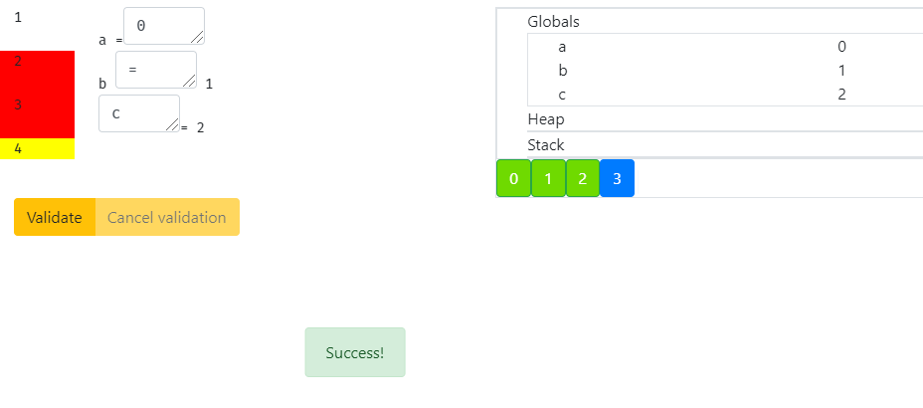

Otherwise, a “Wrong!” red message appears (and in BAs the wrong values of your program are shown in red close to the correct ones in green in the state):

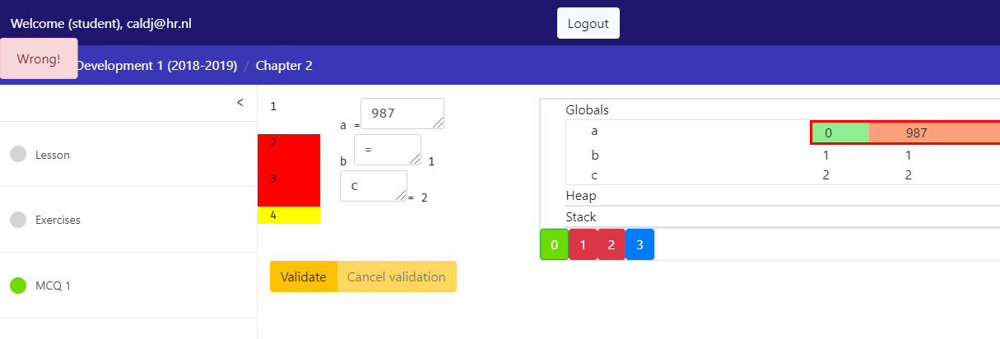

The round icon close to the assignment name in the left column also gets such color (orange for incomplete/wrong and green for complete):

